FTHANKS AI
Global Business Guidelines
With
Terms and Conditions
Current as of December 1st , 2020

This page contains the membership terms and conditions.
Please make sure that you have read and fully understood them.
Company Profile
Director Makoto Fujiwara
Thanks AI Global Pte., Ltd.
8 Eu Tong Sen Street #16-92
The Central Singapore 059818

NFR Customer Service
Hours of Operation
Open: Weekdays (Monday - Friday), 7:30 a.m – 4:30 p.m (Singapore Standard Time)
Closed Saturdays and Sundays
E-mail: nfr@thanksai.jp

Products
Product Name: PERFECT MINERAL AI POWDER
Description: Powder supplement
Contents: 2g × 15 sticks
Price:
Initial purchase price: JPY22,000 (12,000PV) for two packages: equivalent to about USD 200
Repeat purchase price: JPY13,500 (12,000PV) for two packages: equivalent to about USD 125
This product contains a luxurious blend of humic shale minerals (the shortcut to plant-based minerals) and humic shale fulvic acid.
Product Name: HYBRID MINERAL AI
Description: Tablet supplement containing vegetable-based minerals
Contents: 28.8 g (480 mg x 60 tablets)
Price:
Initial purchase price: JPY22,000 (12,000PV) for two packages: equivalent to about USD 200
Repeat purchase price: JPY13,500 (12,000PV) for two packages: equivalent to about USD 125
This product contains an abundant blend of humic shale minerals (the shortcut to plant-based minerals) and the modern vegetable-based mineral "Replan".
Product Name: KAWAII ESSENCE AI
Description: Beauty lotion in an airless container
Contents: 20 ml
Price:
Initial purchase price: JPY22,000 (12,000PV) : equivalent to about USD 200
Repeat purchase price: JPY13,500 (12,000PV) : equivalent to about USD 125
The beauty lotion “Kawaii Essence” is a luxurious blend of beauty ingredients including plant minerals, proteoglycans, plant stem cell culture extract (edelweiss callus culture extract), and hyaluronic acid that gives your skin what it needs. “Kawaii Essence” is a beauty lotion produced meticulously without any additional preservatives that will maximize the potential of your beauty.

Product Name: PROFIL®
Description: Film supplement
Contents: 15 sheets
Price:
Initial purchase price: JPY22,000 (12,000PV) for two packages : equivalent to about USD 200
Repeat purchase price: JPY13,500 (12,000PV) for two packages : equivalent to about USD 125
This is a next-generation film, made with a luxurious blend of ultra-pure proteoglycan, extracted using patented alkaline extraction technology.
Product Name: CANEAL
Description: Tablet supplement
Contents: 29.8 g (497 mg x 60 tablets)
Price:
Initial purchase price: JPY22,000 (12,000PV) for two packages: equivalent to about USD 200
Repeat purchase price: JPY13,500 (12,000PV) for two packages: equivalent to about USD 125
This is a tablet type supplement containing Chitin Chitosan Oligosaccharides.

Product Name: JOYFIL
Description: Film supplement
Contents: 15 sheets
Price:
Initial purchase price: JPY22,000 (12,000PV) for two packages: equivalent to about USD 200
Repeat purchase price: JPY13,500 (12,000PV) for two packages: equivalent to about USD 125
Contains a natural form of active collagen II, which allows you to replenish the cartilage that tends to decrease with age. Carefully made using nasal cartilage from salmon caught in Hokkaido, and contains only valuable naturally-occurring ingredients that are extracted using our unique method.
Product Name: JoeGenEx
Description: JoeGenEx Botanical Extract Mineral Element [Powder food]
Contents: 15 bars/pack
Price:
Initial purchase price: JPY22,000 (12,000PV) for two packages: equivalent to about USD 200
Repeat purchase price: JPY13,500 (12,000PV) for two packages: equivalent to about USD 125
This product is the optimal combination for phytochemicals selected from more than 10,000 varieties of plants. The 3 optimal combinations are integrated to bring about a top-class dietary supplement, among which are 9 “natural botanical extracts”, 13 types of “JoeSyn” and 5 types of “JoeMaF” made with the proprietary ingredients of Thanks AI, leading you to a healthier and wealthier future.

If you would like to buy future orders in bulk, you can choose 3M6M12M up to 3 years.

Purchase plans | 3Mx1 | 3Mx2 | 6Mx1 | 6Mx2 | 12Mx1 | 12Mx2
Product Qty | 3 boxes | 6 boxes | 6 boxes | 12 boxes | 12 boxes | 24 boxes
Gift Qty | 0,5 box | 1 box | 1 box | 3 boxes | 3 boxes | 7 boxes
Product price | 40,500JPY | 81,000JPY | 81,000JPY | 162,000JPY | 162,000JPY | 324,000JPY
PV distribution | 12,000 PV  X  3 months | 24,000 PV  X  3 months | 12,000 PV  X  6 months | 24,000 PV  X  6 months | 12,000 PV  X  12 months | 24,000 PV  X  12 months
Total PV | 36,000 | 72,000 | 72,000 | 144,000 | 144,000 | 288,000
Shipping method | ship all after purchase | ship all after purchase | ship all after purchase | ship all after purchase | ship all after purchase | ship all after purchase
Note: Shipping method & shipping fee:
+ No matter how many 3M6M12Ms members buy at the same time, the shipping fee remains the same
+ One time shipping fee will be applied.
+ The products purchased will be shipped all at once

Sales Configuration
In general, we employ network marketing, which corresponds to "Multilevel Marketing". You may purchase products directly from us at the member price if you are referred to us by a member and register as a member. In addition, members may introduce new members who love our products to receive bonuses (specific profit) based on our company's bonus system.

Membership qualifications
Only Individual can register as a NFR member. Corporate entities (companies) cannot register as NFR member. The following individuals are not eligible for membership.
1. Corporate entities (companies) cannot register.
2. Persons under 20 years of age (Students are not eligible for membership).
3. Persons who are not citizens of a country in the company's pre-marketing area.
4. Persons with connections to gangs or criminal organizations.
5. Persons unable to understand the content of these terms and conditions.
6. In principle, persons who were formerly members and who withdrew less than 6 months ago, who made their last purchase less than six months ago, or who were expelled from the program.
7. Others whom the company has determined to be ineligible for membership.

Resending and Exchanging
*Returning, refund and exchanging of the ordered products do not apply to NFR member.
If the received product does not match the product description or there is a defect/ damage in the product, please follow the procedure below:
- Notify Thanks AI within 30 days of receipt
- Send the product to Thanks AI's warehouse (specified by Thanks AI at the time of receiving exchange request).
- Thanks AI shall confirm the returned product and send out a replacement product as soon as possible.
- All shipping costs will be borne by Thanks AI provided that the above procedure is complied with. Otherwise product cannot be exchanged.
*In case that the products cannot be received for some reasons and be returned to our Japan office, we can resend the products by charging JPY1,300 for the transaction fee and shipping fee to your credit card.
Please contact NFR customer service first before sending back the products.

Charge back
There are some cases that the payment is not allowed to be settled, usually because the card holder requests their card company to do so.
Therefore, payment cannot be received for the product(s) ordered and already delivered to members.
In such a case, we will contact the member as well as his or her sponsor to solve the case.
However, if the member and/or sponsor cannot be contacted by us, which results in the charge back being unsolved, the membership of the member will be cancelled.
Hence, the member will lose all membership rights, including purchasing products and receiving bonus.

Overdue shipment
Please note that it may not be possible to check the delivery status for products that have been placed for more than 6 months.
Rank Degradation
The rank of a month which has already been gained may be degraded due to charge back.
However, the rank will not be degraded if the total quantity (PV) lies within the following limit:

Silver | Triple Silver | Six Silver | Gold | Triple Gold | Six Gold | Diamond | Triple Diamond | Six Diamond | Crown Diamond
24,000PV  (2 boxes） | 36,000PV  (3 boxes） | 60,000PV  (5 boxes） | 84,000PV  (7 boxes） | 144,000PV  (12 boxes） | 240,000PV  (20 boxes） | 360,000PV  (30 boxes) | 720,000PV  (60 boxes) | 1,080,000PV  (90 boxes) | 1,440,000 PV  (120 boxes)

Membership Terms and Conditions
1. Members are independent business owners and do not function as representatives or proxies of this company.
2. It is up to the members whether they will recruit or not. Members may withdraw the program of their own free will, and upon withdrawal they will lose all of their rights as members.
3. It is possible to recruit or reinstate members if 6 months have passed since they withdrew from the program, or have not made any purchases for 6 months or more.
4. If a member has no purchase transaction for a period of 6 months, his/her membership status shall automatically be changed into Revocation.
Revocation members cannot make purchase, recruit new members and receive bonus. They will also lose the right to receive the bonus accrued during their membership period.
Revocation members can re-register online.
5. Membership transfer
Membership can only be transferred to spouse. To carry out this procedure, it is necessary to submit “Member’s Information Change Request” prescribed by Thanks AI and a certificate that can confirm the relationship. The compliance of the heir with the membership conditions and the approval of Thanks AI will also be required. A fee of 3,000 PV equivalent will be charged as a handling fee. After completing the procedure, all rights related to membership will be transferred.
The legal heir of the Member may inherit the membership only in case of the death of Member. To carry out this procedure, you will be required to submit “Member’s Information Change Request” prescribed by Thanks AI together with documentary evidence of the fact of the death and the identity of the legal heir (family register, will, inheritance agreement, etc.). The compliance of the heir with the membership conditions and the approval of Thanks AI will also be required. A fee of 3,000 PV equivalent will be charged as a handling fee. After completing the procedure, all rights related to membership will be transferred.
6. These terms and conditions may be changed for unavoidable reasons, such as social changes or regulations.
7. If a member commits an act that damages the company's honor or reputation or commits an act that is to the company's disadvantage, the member must promptly compensate the company for any damages caused by that act.
8. Any disputes arising between the company and a member shall be the jurisdiction of the court that presides over the company's location.
9. If a member violates the above regulations or commits one of the following prohibited acts, the company may warn the member, make them ineligible to receive bonuses, or expel them from the program.
10. In order to receive commissions, it is necessary to apply for MONEY TRACK debit card. Commissions will be paid to the MONEY TRACK debit card.
For members living in Canada, Korea and China who cannot apply for MONEY TRACK, please apply for Prepaid Card. Please refer to the Prepaid Card button in Fastrack for further details.
11. Changes in the sponsor or the position in the organization are acceptable provided such applications are made within five business days after completion of registration. However, no change is allowed where the registration month needs to be moved backward or forward.” (Example of inapplicable changes: moving member(s) registered in January to be under any member registered in February).

12. Country change
When a member submits a country change request, it means that he/she has read, fully understood and agreed with all rules and regulations of the new country (as specified in the Guidebook of the new country).
In order to change countries, members have to submit all the necessary documents and application forms to the countries he or she is moving to.
Commissions accrued in the previous country must be received in that country and cannot be received in the countries he or she is moving to.
If a member without MONEY TRACK card cannot or do not want to apply for it, he or she has to forfeit his or her commission before changing countries.
For conducting a country change, 3000PV equivalent will be charged uniformly as an Administrative handling fee.
In addition, within 6 months after a country change, members cannot have their country changed again unless they have rational reason (moving to a new residence address, etc) and provide proof of address change.

13. Partner registration
Only people who have registered their own Thanks AI business membership can register a partner.
Members need to submit an application form provided by Thanks AI and a copy of ID.
The spouse registering as a partner must also comply with the membership requirements and be approved by Thanks AI.

After completing the procedure, partners will receive the following benefits:
・Support the business activities of the main contractor.
・Use Member Page (Back Office) for business activities of the main contractor (placing orders, checking organization, etc.).
・Contact Thanks AI’s customer services about inquiries of main contractor’s business information.
・Receive a commendation at the same time at Thanks AI Convention and Events.
・Purchase a pin badge which is of the same rank as the main contractor.

Notes
・Only spouses are eligible for partner registration; other family members are not eligible.
・Partner registration can only be accepted offline.
・Only main contractor can receive various offers, such as campaign awards and pin badge that are given when a rank is achieved.
・Credit card used for product order, delivery address and other necessary documents must be in the name of the main contractor.
・The role of main contractor and partner cannot be exchanged.
・If both spouses are members, the member that becomes partner will be withdrawn.
・Partner can re-register immediately upon divorce, but the previous position cannot be used.
・In case a member has multiple spouses, he/she can register multiple partners.
・If the main partner wants to quit the company, this position cannot be given to sub partner.

・If the sub partner wants to quit “partner registration” to have their own membership position and if it does not involve a divorce
・The main partner can still use this position as it is.
・When and if the sub partner can re-register depends on each country’s rules and regulations on re-registration.

・When checking the last purchase date for the re-registration procedure, the purchase made with the partnership position is to be checked.

Prohibited Acts
1. Duplicate registration is prohibited.
2. You must comply with the Specified Commercial Transactions Act and the Pharmaceuticals and Medical Devices Act and other relevant laws and regulations, and you must not solicit in a manner that conflicts with any of the relevant regulations for any reason whatsoever.
3. You must neither make false statements nor conceal facts about the type and content of products, the cost of purchasing products (specific burden), withdrawal, or the bonus system (specific profit).
4. You must not use examples of successful members to imply that all members are successful.
5. You must neither call nor visit others late at night (after 9:00 pm) or early in the morning (before 8:00 am) without their consent.
6. You must not solicit without explaining the reason for your visit. Furthermore, you must not solicit without presenting identification (such as a business card).
7. You must not make threats when soliciting or to avoid cancellation of a contract.
8. You must not enter non-public places for the purposes of solicitation without announcing the purpose of the solicitation.
9. You must not inconvenience customers, other members, or the company.
10. You must not duplicate or reproduce the company name, logo, trademark, or other copyrighted materials or printed materials without the company's permission.
11. You must not create or distribute advertising, printed materials, tapes, CDs, etc. for the purpose of recruitment without the company's permission. Furthermore, you must not post advertisements in newspapers, in magazines, or on the Internet.
12. You must not use third-party materials not from the company for the purposes of solicitation.
13. You must not record sound or video at meetings, lectures, and seminars hosted by the company without the company's permission.
14. Solicitation - Cross recruitment: You must not participate in solicitation, mediation, or sales of products and services that compete with the company or its members, nor participate in network businesses that compete with the company or its members.
In order to protect the members who devote their time and effort to the activities of Thanks Ai in general and their group in particular, Thanks Ai firmly prohibits solicitation and cross recruitment.
Currently, there is an increasing number of members sharing with Thanks Ai their concern about becoming victims of such violations as introduction, solicitation and interference by companies of the same industry as well as investment-related businesses and services.
Therefore, Thanks Ai has revised some regulations and imposed severe punishment on violators.
Thanks Ai strictly prohibits such violations as follows:
≪ Solicitation ≫
Negotiate and persuade the members who are currently in an organization of Thanks Ai to join other organization.
≪ Cross recruitment ≫
Cross recruitment violators include (1) those having terminated, cancelled or stopped the membership contract with Thanks Ai for a certain period of time but, for any reason, still take advantage of Thanks AI's name to promote services, products, business activities and marketing programs of a third party, (2) those making acquaintance through mutual participation in Thanks Ai's activities, (3) and/or any Thanks Ai members, who commit the following acts:
1. Solicit and introduce other members to other companies of the same industry, or encourage terminating Thanks Ai' activities.
2. Introduce, solicit and mediate investment-related businesses.
In case of violating these prohibited acts or being judged by Thanks Ai to have violated these prohibited acts, bonus payment will be suspended and/ or bonus received during the violation period will be required for refund.
* Please carefully note that if any of the above acts are committed in the performance of this company's business, they may be punishable in accordance with the Specified Commercial Transactions Act.

Handling of personal information
Personal information acquired by the company will be used for the following purposes.
1. To provide information on the company's products and services.
2. To provide information on the products and services of companies and organizations sanctioned by the company.
3. To provide the organization chart to members approved by the company.
4. To provide information that thought to be useful with respect to health and beauty.

Order Method
Allow only online orders (via Back Office or Thanks AI’s Official App) placed in Japan standard time;
Member must place order himself/herself and cannot ask other member(s) to place order for him/her.
Once a member registering in a country, it is not allowable to have product shipped out to another country.
Thanks AI’s Official App can be downloaded on App Store (iOS) and Play Store (Android), or you can read the following QR code:
For iOS:

For Android:

Order Time
Order must be placed by 23:59 p.m. (Japan Standard Time) of the final day of a month in order to be counted as the order of such month.

Payment Method
MONEY TRACK Debit Card (MASTER）or Credit Card（VISA, MASTER, JCB, AMERICAN EXPRESS, DINERS.

How to Receive Bonus
THANKS AI MONEY TRACK
Note: Members from some countries cannot apply for MONEY TRACK. Please check the latest information about this on NFR Website.

Shipping Method
Shipping from Japan by EMS

Shipping Time
Normally, products will be delivered within two weeks, but there is a possibility that delivery takes more than three weeks due to cause of force majeure.

Shipping Cost
Differs depending on shipping destination: JPY1,400 – JPY2,400
Customs Duties（Tax）
Differs depending on product, and shipping destination (Tax will be charged to the purchaser)
Please be noted that members will be responsible for receiving their orders. If the products are stopped at the customs or the post office by contacting these offices directly and paying relevant taxes, if any.

２ Boxes (24,000PV） Registration Present Benefit
Yes (Select at time of registration)

Benefits for Website Registration
N/A
Auto ship
N/A (Only spot orders)

Amount of purchase limitation
NFR purchase is limited to the personal use only. It is strictly prohibited to resale, retail nor hand over.
*You can buy up to the amount that you can use within 2 months for each order.

Bonus Plan (specific profit)
1. In order to receive a bonus in a particular month, you must make your own purchase of at least one box of products (12,000 PV) in that month.
2. By meeting all of the conditions to receive a bonus, you have right to earn bonuses.
3. The company's organizational chain is made up of two simultaneously operating organizational maps, and the maps for calculating each kind of bonus are different.
4. The "Sponsor Bonus", which uses the "Real Map", will accrue when a referral completes his/her registration. The "Pair Bonus", "Balance Bonus", "Global Bonus" and “Season Bonus” which use the "Binary Map", will accrue when at least one directly referred member on each side has purchase 12,000 PV).
5. If the payment rate exceeds 70%, a cap adjustment may be conducted.
Bonus Plan
Glossary of Terms
Here is an explanation of the terms that appear in the Bonus Plan.
-PV
Point Volume
1 PV = 1 PV, 1PV = US$0.009 (using MONEY TRACK)
Subject to change due to exchange rate fluctuations
- Real map
A chart showing the actual order of entry of new registrants.
- Binary map
Always constructed of two rank lines, with the option of whether a new registrant is placed left or right upon referral.
- Position
Indicate each qualified person's position on the map.
- Line
Lines are created in order of registration, and new registrants are always assigned to the left or to the right at time of registration.
- Spillover
New registrants produced by higher level members on the binary map.
- Level
Indicate a tier on the map. There are two types of tier, the actual number of tiers (lowest level) and the number of tiers calculated by bonus (active level).
- Compression
The compression of non-purchasers to count levels when calculating the bonus. This determines active levels.
Product Purchases (specified share)
The number of products purchases is selected upon purchase at time of registration (initial).
If 2 boxes are purchased, 1 box will be given as a bonus.
From the second purchase, onwards, the bonus plan conditions depend on the number of boxes purchased.
 | 1 box purchased | 2 boxes purchased | Repeat purchases
Product price | JPY22,000 | JPY44,000 | JPY13,500
PV | 12,000 PV | 24,000 PV | 12,000 PV
Registration fee | 0 PV | 0 PV | 0 PV
Delivery fees (including postage) | Depends upon the country to be shipped to.
Annual membership fee | 0 PV | 0 PV | 0 PV
Total Amount | JPY22,000 + shipping fee | JPY44,000 + shipping fee | JPY13,500 + shipping fee

* All prices include tax.
* In order to receive a bonus (specific profit), you must satisfy all of the conditions. Purchases are not mandatory and not making a purchase will not result in the loss of your membership. However, if you do not make any purchases for six months, you will automatically become Revocation.
* PV (Point volume) is calculated at 1 PV = USD 0.009

Rank Types and Conditions
Rank is set based on sales in small groups on the binary map (PV) and growth conditions. Opportunities to acquire bonuses increase with rank.
Eligibility condition:
- Member must purchase at least 12,000 PV of product to get rank upgrade;
- Have 2 direct referral purchasers on the real map, and at least each to the left and right of the binary map.

Rank | Small group PV (number of boxes) | Growth conditions
Silver | 120,000 PV (10 boxes) or more | No conditions
Triple Silver | 360,000 PV (30 boxes) or more | No conditions
Six Silver | 720,000 PV (60 boxes) or more | No conditions
Gold | 1,200,000 PV (100 boxes) or more | 2 Silver rank lines on the Real Map make 1 person on each of the left and right sides of the Binary Map
Triple Gold | 3,600,000 PV (300 boxes) or more | Same as Gold
Six Gold | 7,200,000 PV (600 boxes) or more | Same as Gold
Diamond | 12,000,000 PV (1,000 boxes) or more | 2 Gold rank lines on the Real Map make 1 person on each of the left and right sides of the Binary Map
Triple Diamond | 36,000,000 PV (3,000 boxes) or more | 4 Gold rank lines on the Real Map make 2 persons on each of the left and right sides of the Binary Map
Six Diamond | 72,000,000 PV (6,000 boxes) or more | 6 Gold rank lines on the Real Map make 3 persons on each of the left and right sides of the Binary Map
Crown Diamond | 120,000,000 PV (10,000 boxes) or more | Same as Six Diamond
Sponsor Bonus
A bonus that can only be obtained by the sponsor upon a new registration.
3,000 PV when 1 box is purchased by a new registrant. 10,000 PV will be paid when 2 boxes are purchased by a new registrant.
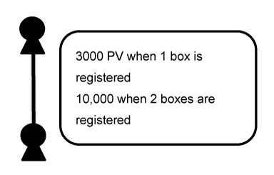
Pair Bonus
Members are eligible to receive a Pair Bonus when there is at least one direct referral on both sides of the members Binary Map, purchasing at least one product in a given month. When calculating the pair bonus, the areas with no purchases will be compressed. Pair bonus can be obtained as a sum of money in accordance with the following table.
However, there is a maximum limit of 300 levels that can be counted as pairs.

Number of personally purchased boxes  Number of  directly referred  member purchasers | Personal purchase of 1 box | Personal purchase of 2 boxes
2 – 3 | 1,500 PV | 3,000 PV
4 – 5 | 2,000 PV | 4,000 PV
6 or more | 2,500 PV | 5,000 PV

* The level is counted after referrals on the binary map who have not made a purchase are compressed.
Example 1: If there are four directly referred purchasers and pairs are lined up to Level 4
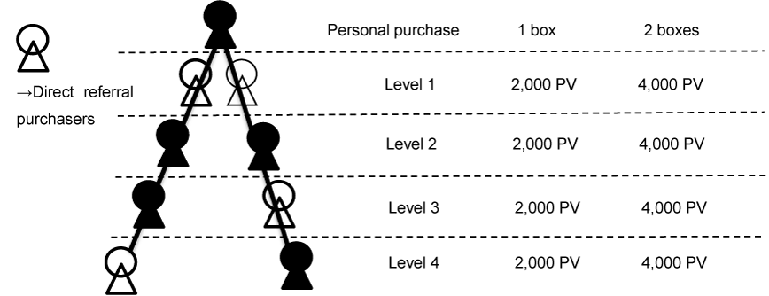
For a personal purchase of 1 box, 2,000 PV x 4 levels = 8,000 PV
For a personal purchase of 2 boxes, a bonus of 4,000 PV x 4 levels = 16,000 PV
Example 2: If there are three directly referred purchasers and pairs are lined up to Level 2
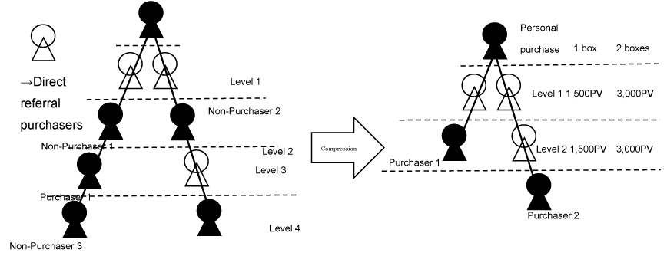
For a personal purchase of 1 box, 1,500 PV x 2 levels = 3,000 PV
For a personal purchase of 2 boxes, a bonus of 3,000 PV x 2 levels = 6,000 PV
Balance Bonus
Balance Bonus is calculated based on the total sales of the member’s right and left group in a given month. A member can qualify to receive balance bonus if the conditions for the Pair Bonus have been met. For each sale of 1 box, the amount shown in the following table can be obtained depending on rank.

Rank | For personal purchase of 1 box |  | For personal purchase of 2 boxes
 | From 1 box in large group | From 1 box in small group | From 1 box in large group | From 1 box in small group
Silver | 50 PV | 300 PV | 100 PV | 600 PV
Triple Silver | 100 PV | 300 PV | 200 PV | 600 PV
Six Silver | 100 PV | 300 PV | 200 PV | 600 PV
Gold | 150 PV | 300 PV | 300 PV | 600 PV
Triple Gold | 200 PV | 300 PV | 400 PV | 600 PV
Six Gold | 200 PV | 300 PV | 400 PV | 600 PV
Diamond | 250 PV | 300 PV | 500 PV | 600 PV
Triple Diamond | 300 PV | 300 PV | 600 PV | 600 PV
Six Diamond | 300 PV | 300 PV | 600 PV | 600 PV
Crown Diamond | 300 PV | 300 PV | 600 PV | 600 PV

* When 3 or more boxes are purchased, boxes from the 3rd box onwards will be added to small group sales.
However, an upper limit is set, depending on rank, for available bonus amounts and number of boxes to be calculated.

Rank | Maximum available
 | Amount | Number of boxes
Silver | 11,000 PV | The maximum for large groups is 5 times the number of boxes sold in small groups
Triple Silver | 48,000 PV
Six Silver | 96,000 PV
Gold | 210,000 PV
Triple Gold | 780,000 PV
Six Gold | 1,560,000 PV
Diamond | 3,100,000 PV
Triple Diamond | 10,800,000 PV
Six Diamond | 21,600,000 PV
Crown Diamond | 36,000,000 PV

Example: For a personal purchase of 2 boxes, rank of Gold, organization of 500 boxes in large group, 200 boxes in small group
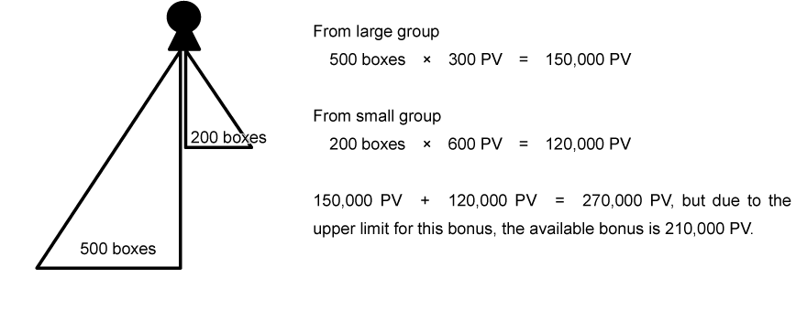

Global Bonus
A bonus, which is the total of the shares for each rank completed and below, and which can be obtained when Triple Gold or higher rank has been achieved.
1% of all global sales for the Thanks Ai Group will be distributed to people who have achieved each of the following ranks.
Example: For total global sales of 1 billion PV (1% = 10 million PV)
Rank achieved | Number of qualified people | Amount of bonus distributed | Amount of bonus obtain
Triple Gold | 100 | 100,000 PV | 100,000 PV
Six Gold | 50 | 200,000 PV | 300,000 PV (100K+ 200K)
Diamond | 20 | 500,000 PV | 800,000 PV (100K + 200K + 500K)
Triple Diamond | 10 | 1,000,000 PV | 1,800,000 PV (100K + 200K + 500K + 1M)
Six Diamond | 5 | 2,000,000 PV | 3,800,000 PV (100K + 200K + 500K + 1M + 2M)
Crown Diamond | 1 | 10,000,000 PV | 13,800,000 PV (100K + 200K + 500K + 1M + 2M + 10M)

Season Bonus
We shall allocate 1% of global sales as a bi-annual Season Bonus in June and December of every year to the members whose ranking is higher than Gold Rank more than three times in the six months prior to the allocation month (June and December) to receive the bonus.

[Target months]
If the allocation month is June -> six months from December of the previous year to May
If the allocation month is December -> six months from June to November
[Calculation Example]
If global sales achieved six billion PV (six-month total) and the number of members who achieved the Gold Rank more than three times was 300 members, the Season Bonus would be 6,000,000,000 PV x 1% / 300 people = 200,000 PV (2 times chance in a year).

Bonus Payment
- All bonuses will be paid into MONEY TRACK*1 (debit card) on the 25th of the following month (the previous working day if that day is a holiday for the financial institution).
- Business Account Management Fee
Members have to pay an equivalent worth of 500 PV deducted from the bonus at the time of commission transfer as a Business Account Management Fee.
Business Account Management Fee will not be charged when commission is less than 2,500 PV equivalent. This fee is charged only in the month when the total amount reaches 2,500 PV equivalent or more and the bonus transfer is made.
- Global Calculation Fee
Since revenues made outside of members’ registered countries must be transferred back, a Global Calculation Fee will be applied and calculated for each member based on the percentage of overseas sales figure in one’s own binary organization. The Global Calculation Fee is equal to 10% of such percentage over total commission of the member.
For a certain member, the calculation will be as follows:
Consider the percentage of overseas sales figure in one’s own binary organization as A%
- Global Calculation Fee = 10% × [A% × (total commission)]
For example:
In the organization of member X in October 2019, total sales volume is 1,000,000 PV.
Overseas sales of his organization is 50,000 PV, which accounts for 5% of his organization’s total sales volume.
His October commission is 200,000 PV.
Global calculation fee = 10% × [5% × 200,000PV] = 1,000 PV
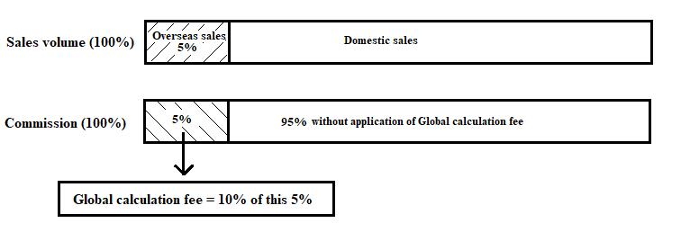
- If your bonus is less than 2,500 PV, it will be retained by Thanks AI and paid once your cumulative total reaches 2,500 PV.
- In case your cumulative bonus is 2,500 PV or more, but you cannot receive bonus for any reason (no card registered, wrong card registration information, etc), the bonus will be retained. Member can receive the retained bonus in the next month accruing bonus or when making special payment request to Thanks AI via nfr@thanksai.jp.
- If the bonus cannot be paid due to some reasons, the payment will be added and paid with the following month's bonus. Please register MONEY TRACK by then. However, if you apply separately and pay a separate handling fee of 500 PV, you can receive payment without waiting for the next bonus.
- The holder of the MONEY TRACK account must be the person registered. You cannot designate another person.
- Bonus is retained by Thanks AI for one year from the date of bonus accruing. In case members become Revocation, they will lose the right to receive the bonus accrued during their membership period.
- Bonuses must be declared to the tax office. Please be sure to do so.
- If there is a charge back in your downline, your bonus may be adjusted accordingly based on the Rank Degradation rule.

Necessary contributions to the Farming Literacy Association
Thanks AI is actively engaged in activities that are beneficial to the natural environment and return our soil to its abundant state in various countries through Farming Literacy Association. Thanks AI members are giving a support by means of 1% donation from their commission in the spirit of “Farming Literacy”. In addition, many people have carried out educational activities in various location and laid the foundation to harvest a safe and secure craft. Farming Literacy Association allows the members to participate in Thanks Ai activities. In the near future, Thanks Ai is planning to support and bring the foundation in your country to benefit the local farmers.
- You can also opt not to receive your bonus, but to donate it to a non-profit volunteer group or charitable organization. Please let us know if you would like to do this. Thanks Ai will donate the amount to be deposited to the above organization.

MONEY TRACK
MONEY TRACK is a global payment system equipped with a MasterCard function that enables the global payment of bills for product and bonuses.
When you use MONEY TRACK, it enables us to calculate common global bonuses and payments.
You can withdraw cash in more than 100 currencies from more than 3 million ATMs around the world.
In addition, you can make a payment in one of more than 35 million MasterCard affiliated stores around the world.
An online MONEY TRACK (debit card) account takes a few days to open (for the card to arrive) after application, so any bonuses arising before that time will be carried over and paid to members when their MONEY TRACK accounts are active.
If you would like to receive payment to MONEY TRACK, please complete the MONEY TRACK application. The change should be received by the 5th of that month.
- There is a designated fee for bonus payments and withdrawals from ATMs.

■ MONEY TRACK Debit Card Processing Charges
Card Account Processing Charges
Processing Charge Item | Amount | Unit | Details
Card Validation | $ 12.95 | Per Card | At first time deposited to card.
Card Validation  *For countries listed at left side | $ 24.95 | Per Card | At first time deposited to card.  BELARUS, IVORY COAST, ECUADOR, ETHIOPIA, MACEDONIA, PAKISTAN, ZIMBABWE
At Bonus payment | $ 3.00 | Per Deposit | At each time bonus is deposited to card.
Monthly Card Account Management | $ 3.00 | Monthly | When the previous month’s orders are 4 or less.
Monthly Card Account Management | $ 1.00 | Monthly | When the previous month’s orders are 5 or more.
Alternate Card | $ 12.95 | Per Card | When issuing the alternate card.

Processing Charges for ATM Cash Withdrawals and Other Transactions
Processing Charge Item | Amount | Unit | Details
ATM Withdrawal  POS Purchase  Cash withdrawal from bank teller | $ 3.15 | Per Transaction | When making withdrawal or payment request.
ATM Declined | $ 1.00 | Per Transaction | When withdrawal request is declined.
ATM Balance Check | $ 1.00 | Per Transaction | When you check your balance at ATM.
*Please note that extra charges may apply depending on the ATM or POS service provider.
Direct Bank Transfer
Processing Charge Item | Amount | Unit | Details
Bank Account Transfer | $ 1.50 | Per Transfer | Charges at every transfer.
■ PV Rate
1PV＝US$ 0.009

[Important Notes: Please make sure to read]
Revisions may be made according to political, legal and regulatory conditions in the global market countries that we operate in.
*These guidelines are based on an NFR (private import) business development model. They do not apply when the targeted countries’ market will officially open.
*Changes (new markets, suspension of service) to the global market countries that we operate in may be made according to the political and legal conditions, logistics infrastructure, security climate, etc. in those countries.
*MONEY TRACK processing charges may be changed or revised in line with directives or instructions from affiliated credit card companies, settlement communication infrastructure services, and the financial services agencies of relevant countries.
*Global business is managed and operated by THANKS AI GLOBAL PTE. LTD. (SINGAPORE).
*If you have any questions or concerns, please contact NFR customer service at nfr@thanksai.jp.

