HOW TO RESET PASSWORD ON BACKOFFICE

- In Fastrack’s screen, click “Forgotten your password? Click here”
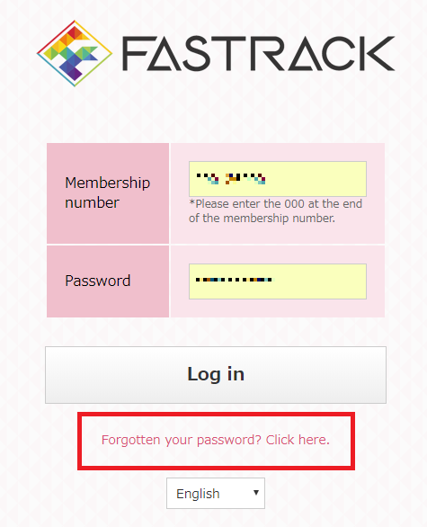

- The reset password screen will be displayed
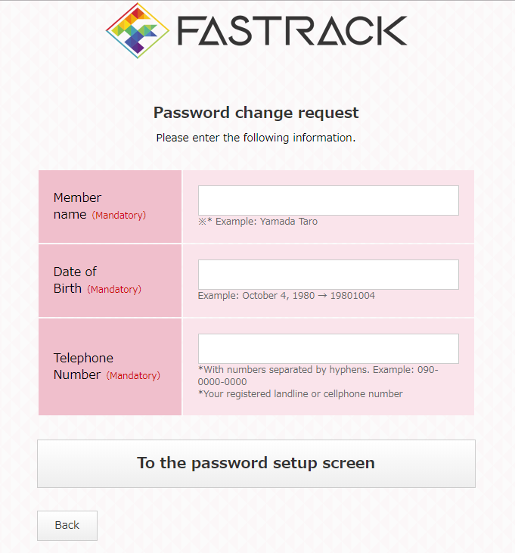
- In the reset password screen, fill in necessary information:
- Member name
- Date of birth
- Telephone number

- In “Member name” item, please input exactly your registered name
Example:
Your registered name: Yamada Taro
→ Member name: Yamada Taro
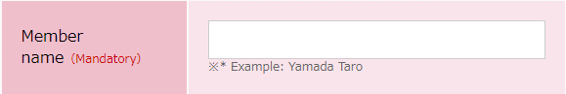

- In “Date of Birth” item:
- Please input exactly your registered date of birth, do not need to put any space or hyphen, etc. between figures.
- Please input in this form: YYYYMMDD
Example:
Your registered date of birth: November 23th, 1995
→ Date of birth: 19951123
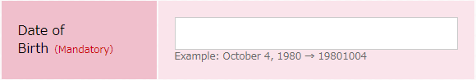
- In “Telephone number”:
- Please input exactly your registered telephone number
- Do not need to input space, hyphen, etc. between figures
Example:
Your registered telephone number: 0123456789
→ Telephone number: 0123456789
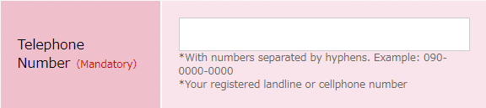

- After inputting all neccesary information, click “To the password setup screen”
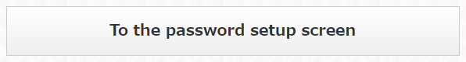

In case information is not input sufficiently, the warning screen will be displayed:
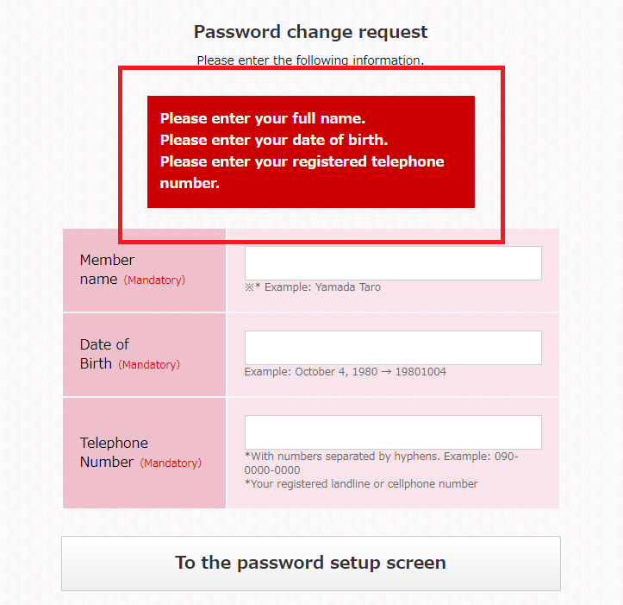
In case incorrect registered information is input, you will see a displayed screen as below:
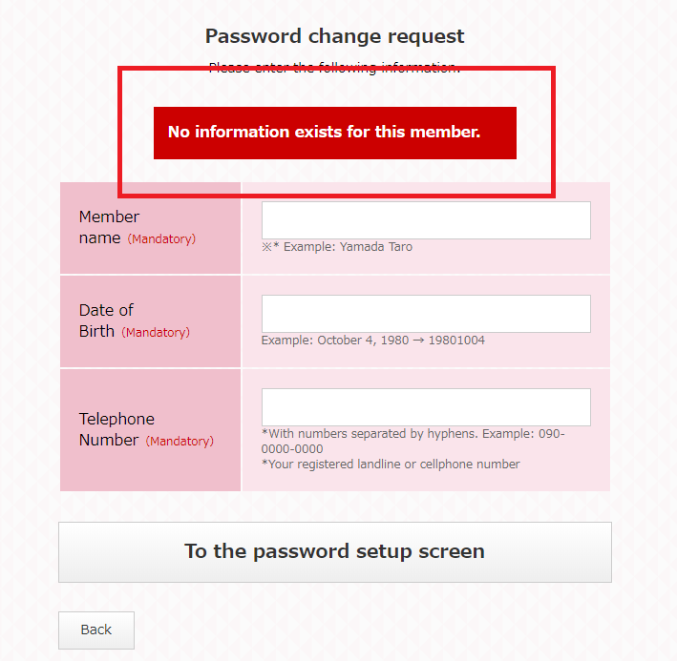
- After inputting all correct information and clicking “To the password setup screen”, the password setup screen will be displayed. Please input your new password then click “Set your paswword”.
